CASE STUDY ANALYSIS REPORT

Software Engineering — CO1 Assessment (AT-1)

AI-Driven Urban Flood Monitoring and Risk Assessment Platform

Name: M DEVI VARA PRASAD
Register No.: 192365032
Department: CSE-CS (Computer Science
Engineering — Cyber Security)
Institution: Saveetha School of Engineering,
SIMATS
Course: Software Engineering
Assignment: Case Study Analysis (CO1_AT-1)
Problem Title: AI-Driven Urban Flood Monitoring and
Risk Assessment Platform
Date: 20 July 2026

Problem Understanding

Problem Explanation
Rapid urbanization, shrinking natural drainage, and increasingly erratic rainfall patterns have made urban flooding a recurring crisis in Indian cities. When heavy rain falls faster than drains can carry it away, streets, subways, and low-lying neighbourhoods flood within minutes, disrupting transport, damaging property, and in severe cases costing lives. Today, most municipal corporations still learn about flooding only after it has already happened — through phone complaints, news reports, or field staff physically checking waterlogged spots — which leaves almost no time to warn residents or redirect emergency resources.
The proposed platform closes this gap by continuously pulling in data from rainfall and water-level sensors, drainage-network monitors, satellite imagery, and weather forecasts, then using AI models to predict which areas are likely to flood before they actually do. Predicted risk is displayed on a live GIS map, automatic alerts go out to both citizens and disaster-management staff, and the system helps planners decide where to send pumps, barricades, and rescue teams first.

Objectives of the Proposed System

    - Continuously monitor rainfall and water levels using IoT sensors across the city.
    - Predict flood-prone areas ahead of time using AI/machine-learning models.
    - Visualize flood risk on an interactive GIS map for quick situational awareness.
    - Generate early-warning alerts for both citizens and emergency authorities.
    - Assist emergency response teams in planning evacuation and resource deployment.
    - Monitor the condition of drainage networks to flag blockages or overloads.
    - Provide real-time analytics dashboards summarising city-wide flood status.
    - Improve overall disaster preparedness and reduce flood-related economic loss.

Scope of the Problem

The platform's scope covers city-wide flood monitoring and prediction for municipal corporations and disaster-management agencies — including rainfall/water-level sensing, drainage-condition tracking, satellite and weather-forecast integration, AI-based risk prediction, GIS visualization, alerting, and support for evacuation and resource-deployment decisions. It is a decision-support and early-warning system: it does not control physical flood-defence infrastructure (pumps, gates, barriers) directly, nor does it replace the judgement of trained disaster-management officials, who remain responsible for final evacuation and deployment decisions.

Key Stakeholders and Challenges

An effective flood monitoring platform depends on coordinated action across several stakeholder groups, each with different responsibilities and constraints during a flood event. The table below summarises the primary stakeholders identified for this system.
Table 1: Stakeholder Analysis for the Proposed System

Stakeholder | Role / Responsibility | Key Challenges Faced
Municipal Corporation  / Disaster Management Agency | Owns and operates the platform; makes evacuation and resource-deployment decisions. | Limited real-time visibility across a large city and pressure to respond within minutes.
IoT Sensor & Infrastructure Team | Installs and maintains rainfall, water-level, and drainage sensors citywide. | Sensor damage, vandalism, and connectivity gaps in flood-prone low-income areas.
AI / Data Science Team | Builds and continuously retrains the flood-prediction models. | Need for large historical flood datasets and accurate short-term rainfall forecasts.
GIS Analysts | Maintain the flood risk map layers and drainage network geodata. | Keeping drainage and elevation data up to date as the city expands.
Emergency Response Teams | Deploy pumps, barricades, and rescue personnel based on system alerts. | Coordinating multiple teams quickly when several areas flood simultaneously.
Citizens / Commuters | Receive alerts, avoid flood-prone routes, and evacuate when instructed. | Alert fatigue, language barriers, and limited smartphone access in some areas.

Stakeholder | Role / Responsibility | Key Challenges Faced
Weather Department (IMD) | Supplies rainfall forecasts and meteorological data feeds. | Forecast uncertainty at the very local, street-level scale the platform needs.

Analyze the Current Approach

Existing System / Current Process

Most Indian cities currently rely on a mix of isolated rain-gauge stations, occasional manual drain inspections, and citizen phone complaints to detect flooding. Some municipalities operate a handful of automatic water-level sensors at major water bodies, but data from these stations is rarely combined with drainage condition, weather forecasts, or GIS terrain data. Flood warnings, where they exist, are typically issued
city-wide or district-wide rather than for specific streets or neighbourhoods, and are often announced only after flooding has already begun.

Strengths of the Current System

    - Existing rain-gauge and river-level stations provide a baseline of real, measured data.
    - Local ward staff and citizens have valuable on-ground knowledge of chronic waterlogging spots.
    - Simple to operate and does not depend on complex AI infrastructure.

Limitations of the Current System

    - Sparse sensor coverage means many low-lying pockets have no monitoring at all.
    - Data from rainfall, drainage, and river-level sources is not integrated into one view.
    - Warnings are reactive — issued after flooding starts rather than predicted in advance.
    - No street-level or neighbourhood-level risk visualization for targeted response.

    - Manual reporting delays mean emergency teams often arrive after conditions have worsened.
    - No systematic way to learn from past flood events to improve future predictions.

Gaps That Need to be Addressed

The central gap is the absence of an integrated, predictive, and geographically precise flood monitoring system. Current approaches detect flooding as it happens rather than forecasting it, and they lack a unified data layer connecting rainfall, drainage health, and terrain. These gaps directly motivate the proposed AI-driven platform, which is designed to fuse all of this data and generate advance, location-specific warnings.

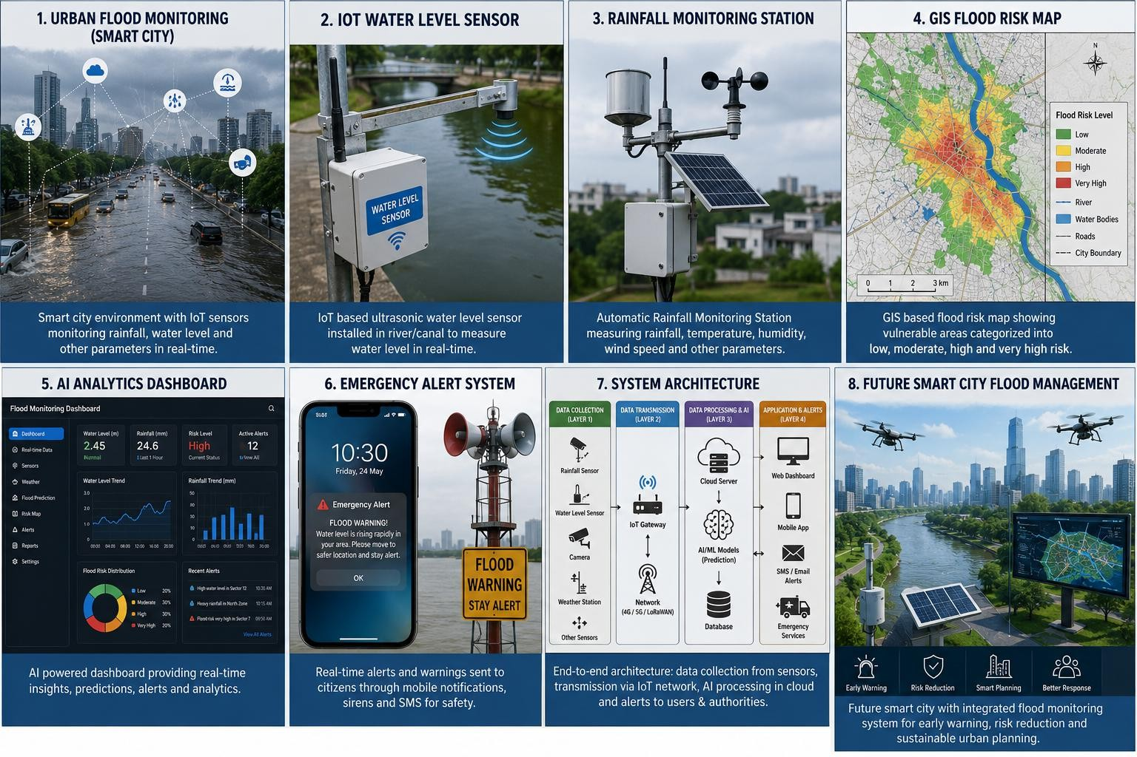

Proposed Solution Using Software Engineering Principles

Solution Overview
The proposed solution is a cloud-connected, modular platform that fuses IoT sensor data, drainage-network status, satellite imagery, and weather forecasts into a single AI-driven flood-prediction pipeline. Predicted risk levels are rendered on a GIS map and drive an automatic alerting module, while a dashboard gives municipal and disaster-management staff a real-time, city-wide view to coordinate emergency response and resource deployment.

Major Functional Modules

    - IoT Data Acquisition Module — collects rainfall, water-level, and drainage sensor readings.
    - Data Ingestion & Preprocessing Layer — cleans, timestamps, and normalises incoming sensor and forecast data.
    - AI Flood Prediction Engine — a time-series/ML model that forecasts flood risk per zone.
    - GIS Flood Risk Mapping Module — visualises predicted risk levels geographically.
    - Early Warning & Alert Generation Module — triggers SMS/app/siren alerts based on risk thresholds.
    - Emergency Response & Resource Deployment Module — helps plan evacuation routes and allocate pumps, barricades, and rescue teams.
    - Analytics Dashboard — presents real-time and historical flood statistics to administrators.
    - Admin / User Management Module — manages roles and access for municipal and emergency staff.

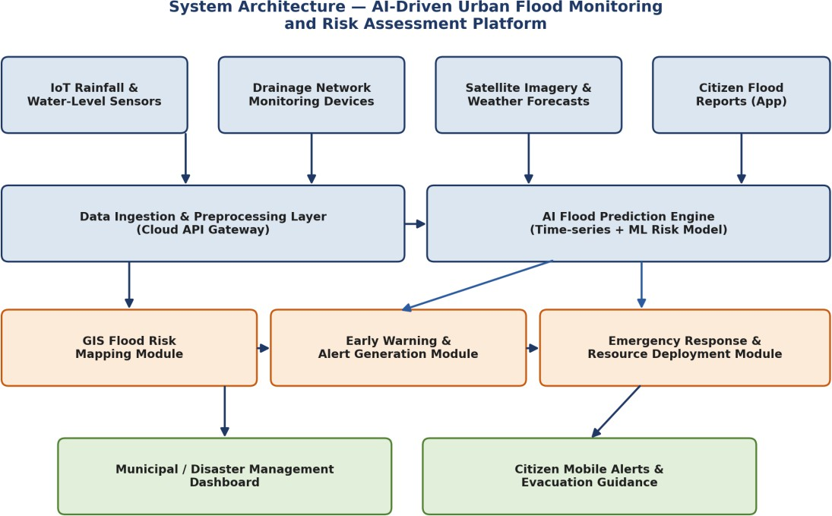

Figure 1: Proposed system architecture showing data flow from IoT sensors through AI prediction to emergency response.
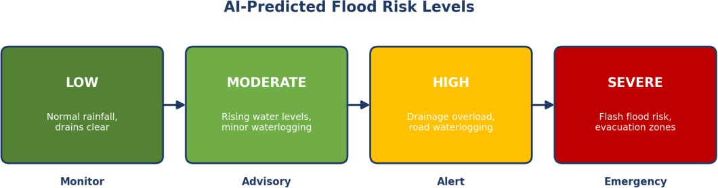

Figure 2: AI-predicted flood risk levels used to trigger alerts and response actions.

Functional and Non-Functional Requirements

Table 2: Functional and Non-Functional Requirements

Type | Requirement
Functional | The system shall collect real-time data from rainfall and water-level IoT sensors.
 | The system shall monitor drainage network conditions and flag blockages or overloads.
 | The system shall predict flood-prone areas using AI/ML models trained on historical and live data.
 | The system shall visualize predicted flood risk on an interactive GIS map.

Type | Requirement
 | The system shall generate and dispatch early-warning alerts to citizens and authorities.
 | The system shall support emergency response planning, including evacuation and resource deployment.
Non-Functional | Scalability — the platform must expand to cover new sensor zones as the city grows.
 | Reliability — the system must continue operating and alerting even during network disruptions common in storms.
 | Usability — dashboards must be clear enough for emergency staff to use quickly under pressure.
 | Security — sensor data feeds and citizen alert channels must be protected from tampering or spoofing.
 | Performance — flood-risk predictions must update fast enough to give meaningful advance warning.

Application of Software Engineering Principles

    - Modularity — sensor ingestion, AI prediction, GIS mapping, and alerting are independent modules that can be updated or scaled separately.
    - Scalability — a cloud backend and containerised services let the platform add new sensor zones or entire new cities without redesign.
    - Maintainability — well-documented APIs between modules make it easy to retrain prediction models or add new data sources.
    - Reliability — redundant data pipelines and offline-alert fallbacks (SMS) keep warnings working even during network outages.
    - Usability — a simple, map-first dashboard lets emergency staff assess risk at a glance under time pressure.
    - Security — encrypted sensor communication and role-based access prevent tampering with alerts or public panic from spoofed warnings.

Justification of the Chosen Methodology

Selected Framework: Agile (Scrum)
The Agile (Scrum) methodology has been selected for this platform.
Development proceeds in short sprints of two to three weeks, each delivering a working increment — for example, one sprint may integrate the rainfall-sensor feed, the next may deliver an initial risk-prediction model, and a later sprint may add the GIS visualization layer.

Why Agile Suits This Project

    - Flood-prediction models must be retrained regularly as more storm data is collected
— Agile's iterative sprints fit this naturally.
    - Requirements from disaster-management authorities are likely to evolve once they start using real dashboards during monsoon trials.
    - Short sprint reviews catch problems early, such as a sensor zone with poor prediction accuracy, before they affect the whole rollout.
    - Independent modules (sensors, AI, GIS, alerting) can be built and integrated incrementally by different sprint teams.

How Agile Supports Development and Maintenance

Agile's short feedback loops let disaster-management staff test each new feature
— such as alert thresholds or evacuation-route suggestions — as soon as it is built, so mismatches with real operational needs surface early rather than after a costly full deployment. For long-term maintenance, Agile's culture of retrospectives and incremental releases makes it easy to schedule model-retraining sprints after each monsoon season as new flood data becomes available.

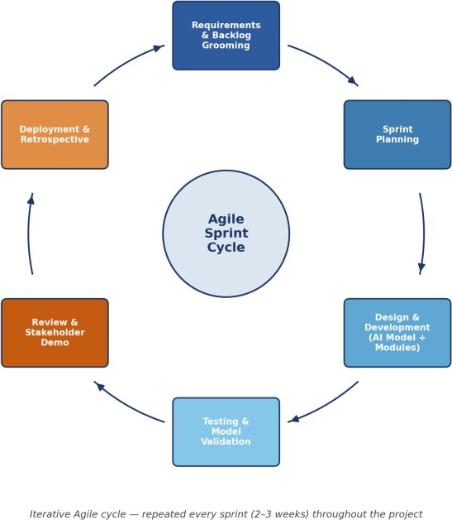

Figure 3: Agile sprint cycle followed for iterative development of the sensor, AI, and GIS modules.

Expected Outcomes and Limitations

Expected Benefits

    - Earlier, more accurate flood prediction than manual, reactive monitoring.
    - Faster emergency response through automatic alerts and clear risk visualization.
    - Reduced flood-related damage to property, transport, and infrastructure.
    - Improved public safety through timely, targeted evacuation guidance.
    - Better long-term infrastructure planning using historical flood-risk analytics.
    - More efficient allocation of pumps, barricades, and rescue personnel.
    - Greater overall urban resilience to increasingly unpredictable rainfall patterns.

How the Solution Addresses Identified Challenges

By fusing sensor, drainage, satellite, and forecast data into one AI prediction pipeline, the platform directly solves the fragmentation and reactive timing identified in

Section 3. Street-level GIS risk visualization gives authorities the precise, advance information that current isolated stations and manual reports cannot provide.

Potential Risks and Implementation Challenges

    - Sensor reliability — flood conditions themselves can damage or submerge monitoring hardware.
    - Prediction accuracy — AI models may struggle with extreme, unprecedented rainfall events outside their training data.
    - Connectivity — storms often disrupt the very networks the alert system depends on.
    - Initial cost — citywide sensor deployment and cloud infrastructure require significant upfront investment.
    - Public trust — false alarms or missed events can reduce citizen confidence in alerts over time.

Future Enhancements

    - Incorporating crowd-sourced citizen reports and social media signals to supplement sensor data.
    - Adding automated control of smart drainage pumps and gates triggered directly by AI predictions.
    - Extending predictions further ahead using improved short-term hyperlocal weather forecasting.
    - Integrating with city traffic systems to automatically reroute vehicles away from flooding roads.

References

National Disaster Management Authority. (2023). Urban flooding guidelines.
Government of India.
Mosavi, A., Ozturk, P., & Chau, K. (2018). Flood prediction using machine learning models: Literature review. Water, 10(11).

Central Water Commission. (2022). Flood forecasting and early warning system manual. Government of India.
Zhang, D., et al. (2025). AI-based urban flood early warning systems: A review. Journal of Hydrology.
India Meteorological Department. (2026). Rainfall and weather forecasting data services.

Word Count: approximately 1500 words (excluding title page, tables, and references).

